## Views (SFO View Browser) ☑

The SFO Revit template files have a built in SFO View Browser to sort views and sheets in a project. The “View Series” and “View Type” Project Parameters are used to sort views, “Sheet Series” and “Sheet Type” serve to sort sheets.

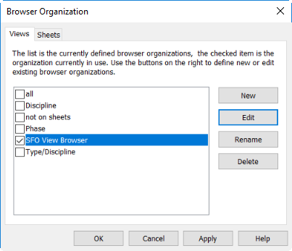

Figure 4.1‑1 SFO View Browser